Smart Office Assistant powered by Watson Assistant

Domain : Artificial Intelligence

### **Abstract:**

the purpose of chat bots is to support and scale business teams in their relations with customers. It could live in any major chat applications like Facebook Messenger, Slack, Telegram, Text Messages, etc.

Chatbots may sound like a futuristic notion, but according to Global Web Index statistics, it is said that 75% of internet users are adopting one or more messenger platforms. Although research shows us that each user makes use of an average of 24 apps a month, wherein 80% of the time would be in just 5 apps. Undoubtedly among them are Facebook Messenger, Snapchat, Whatsapp, WeChat etc. This means you can hardly shoot ahead with an app, but you still have high chances to integrate your chatbot with one of these platforms.

### **Tool : Watson Assistant**

Watson Assistant is IBM’s AI product that lets you build, train, and deploy conversational interactions into any application, device or channel.

Most chatbots try to mimic human interactions, which can frustrate users when a misunderstanding arises. Watson Assistant is more. It knows when to search for an answer from a knowledge base, when to ask for clarity and when to direct users to a human. Watson Assistant can be deployed in any cloud or on-premises environment – meaning smarter AI is finally available wherever you need it.

### **Steps to Design Smart office assistance chat bot:**

1. Login to smart intern

## Intent:

A intent reflects the objective or purpose of a sentence

**Create intents:**

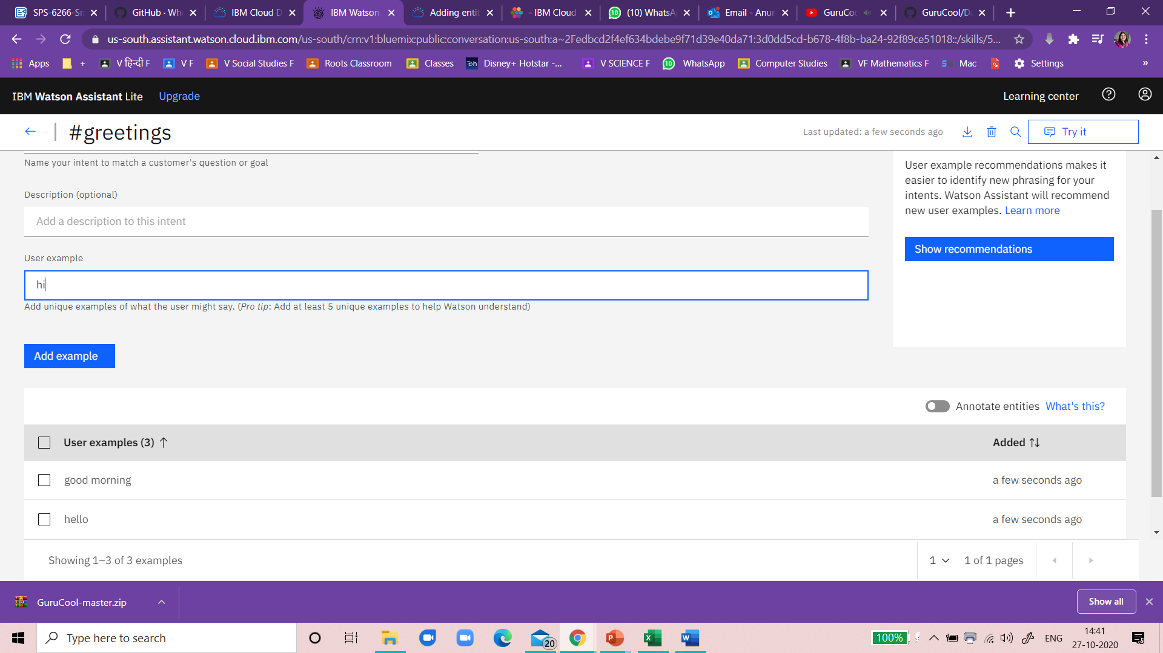

Create Entities:

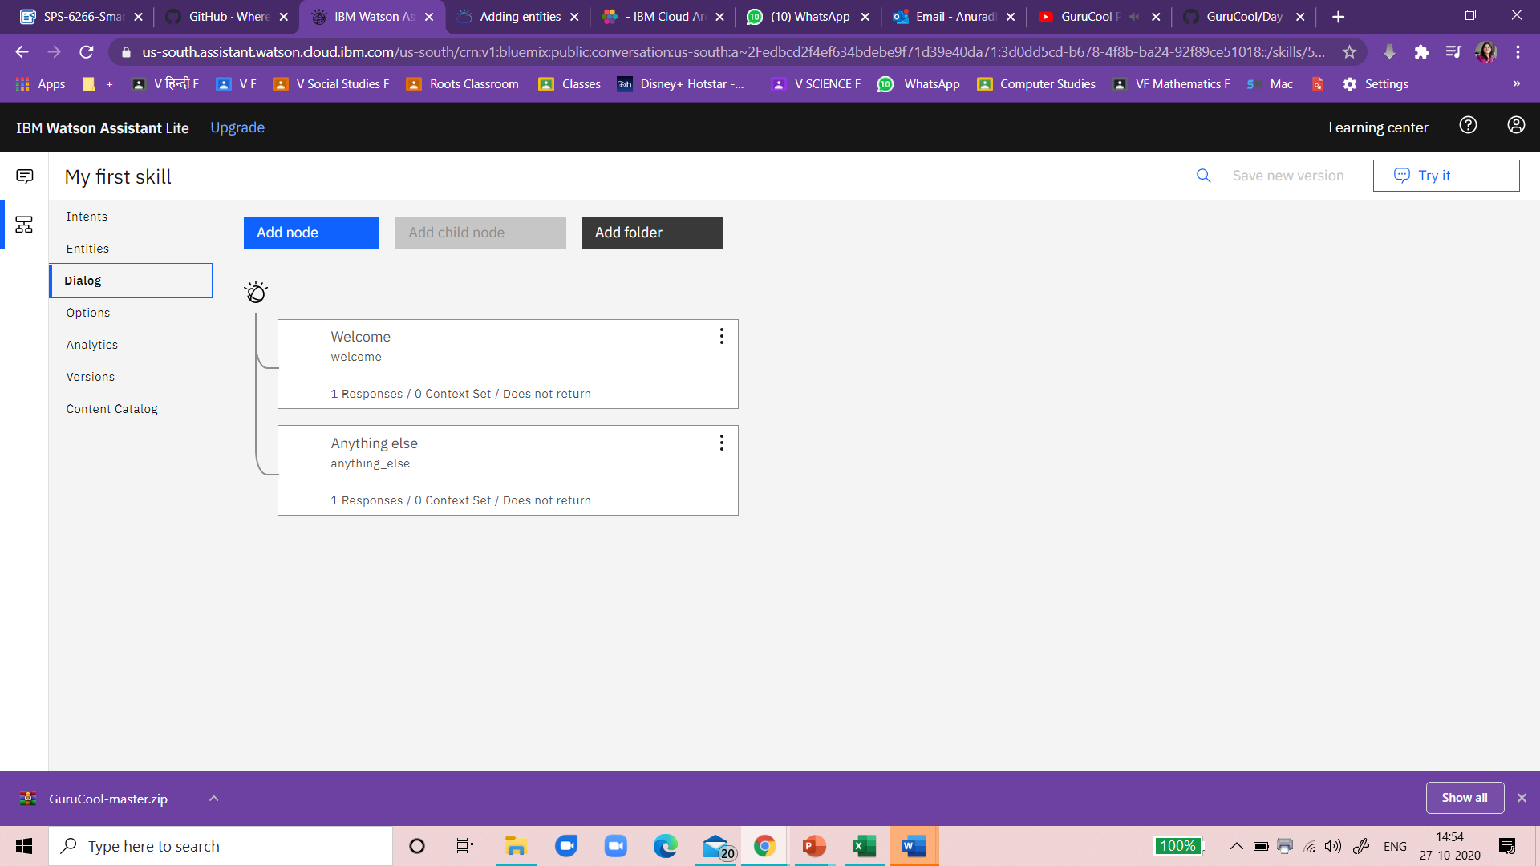

Add assistant Response

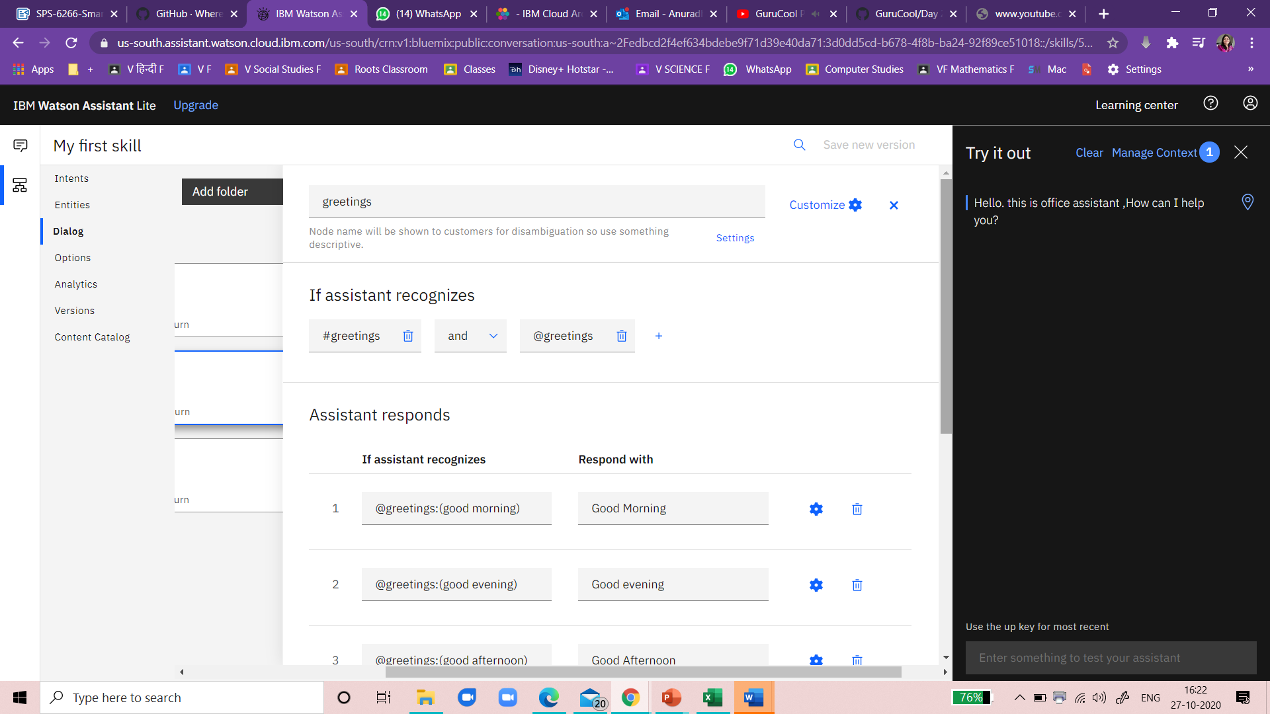

### **Chatbot URL :**

https://web-chat.global.assistant.watson.cloud.ibm.com/preview.html?region=us-south&integrationID=fb356714-b455-485a-b26c-9ac514d04437&serviceInstanceID=3d0dd5cd-b678-4f8b-ba24-92f89ce51018

